EXPERIMENT 6
AIM: To design an interactive Executive Dashboard and Business Scorecard using Microsoft Power BI for monitoring organizational performance and supporting business decisions.
OBJECTIVES:
- Develop interactive dashboards using Power BI.
- Create KPI-based business performance scorecards.
- Analyze organizational performance using visualizations.
THEORY:
A Dashboard presents important business metrics and trends in a consolidated visual interface. A Scorecard compares actual performance against predefined targets using Key Performance Indicators (KPIs). Power BI provides interactive cards, charts, slicers, and conditional formatting for effective business performance monitoring.
DATASET USED:
Global Superstore Dataset (Excel) containing sales, profit, orders, customers, products, regions, and dates.
PROCEDURE:
- Open the previous Experiment 5 Power BI project and save a separate copy for Experiment 6.

- Identify business KPIs and plan the Executive Dashboard layout.

- Create KPI cards for Total Sales, Total Profit, Total Orders, and Profit Margin.
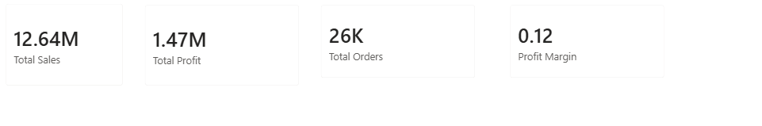
- Develop charts for Sales by Region, Sales by Category, Monthly Sales Trend, Top 10 Customers, and Profit by Segment.
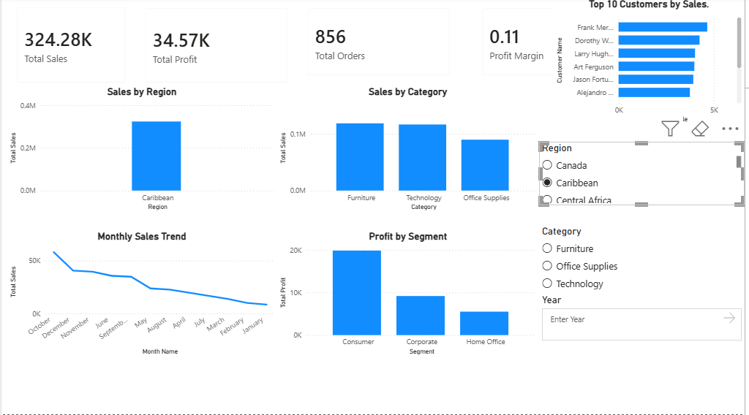

- Format dashboard visuals for consistency and readability.

- Add Region, Category, and Year slicers and test their interactive functionality.
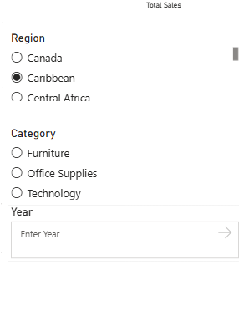
- Create a Business Scorecard comparing actual sales, profit, and orders against targets.
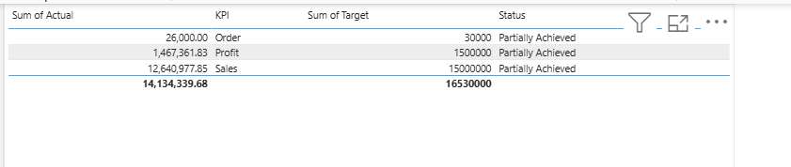
- Apply conditional formatting and performance indicators to the scorecard.
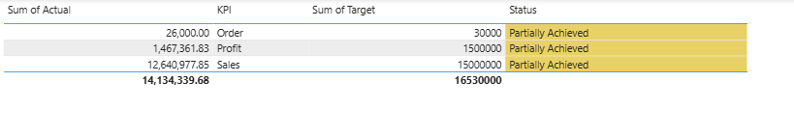
- Analyze regional and category performance and provide a business recommendation: “Global Superstore should focus on improving sales in underperforming regions such as Caribbean and strengthen its profitable Technology category. Targeted marketing and cost-control strategies can improve overall business profitability.”

RESULT:
An interactive Executive Dashboard and Business Scorecard were developed successfully using Power BI, enabling KPI monitoring, performance comparison, and data-driven business analysis.
LEARNING OUTCOMES:
- Designed interactive dashboards using Power BI.
- Created KPI-based business performance scorecards.
- Analyzed business performance and identified improvements.

